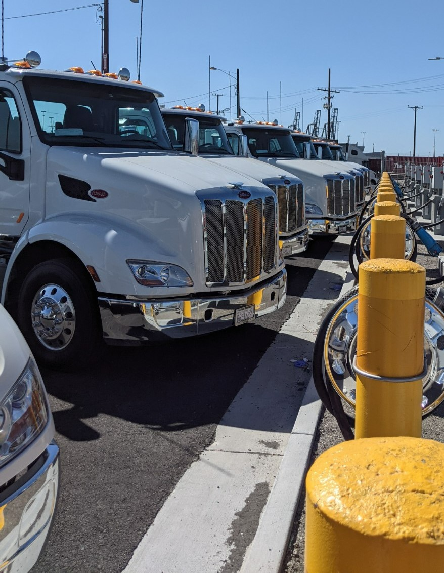

Port of Oakland Green Power Microgrid Project

Trade Corridor Enhancement Program Project Application Cycle 3
California Department of Transportation, Port of Oakland, and Metropolitan Transportation Commission
November 2022
Table of Contents
A. Cover Letter 3
B. Fact Sheet 4
C. General Information 6
C.1 Project Overview 6
C.2 Project Location 8
C.3 Project Priority 8
C.4 Project Scope 8
C.5 Independent Utility 9
C.6 Project Consistency with Regional Transportation Plan (RTP)/Sustainable Communities Strategy (SCS) 10
C.7 Nominating Agency/Implementing Agency Agreement 10
D. Screening Criteria 11
D.1 Project Eligibility 11
E. Project Delivery 13
E.1 Delivery Method 13
E.2 Contracts 13
E.3 Schedule Risks 13
E.4 Railroad Company Coordination 13
E.5 California Environmental Quality Act (CEQA)/National Environmental Policy Act Status 14
F. Evaluation Criteria 15
F.1 Freight System Factors 15
F.2 Transportation System Factors 15
F.3 Community Impact Factors 19
F.4 Other Criteria 25
G. Other Project Information Areas 29
G.1 Accessibility 29
G.2 Climate Change Resilience and Adaptation 29
G.3 Protection of Natural and Working Lands, and Enhancement of the Built Environment 30
G.4 Public Health 31
H. Funding and Deliverability 32
H.1 Funding 32
H.2 Total Project Cost 33
H.3 Committed/Uncommitted Funds 33
H.4 Cost Overruns 33
H.5 Contracts 33
H.6 Preconstruction Requests 33
H.7 Federal Grants 33
H.8 Ineligible Elements 33
I. Other 34
I.1 Public/Private Benefits 34
I.2 Interagency Cooperation 34
I.3 Bulk Coal 34
1.4 Reversible Lanes 34
Appendix A: Performance Indicators and Measures 35
Appendix B: Performance Measures Required Back-Up Information 38
Appendix C: Project Programming Request 47
Appendix D. State Highway Project Impact Assessment (Form CTC-0002) 48
Appendix E: Letters of Support 49

A. Cover Letter

TO BE REPLACED WITH FULLY SIGNED COVER LETTER (INCLUDING CALTRANS DIRECTOR SIGNATURE)

B. Fact Sheet

Port of Oakland Green Power Microgrid Project

Project Scope
In 2019, the Port of Oakland formalized its commitment to becoming a zero-emissions port. The Green Power Microgrid Project implements Intermediate-Term (2023-2030) actions of the Pathway to Zero Emissions Plan:
- 145 heavy duty/Class 8 electrical vehicle chargers at 7 locations for yard, dockside, and transient vehicle use, increasing the number of zero-emissions vehicles (ZEV) that can be supported from 50 to over 1,000
- Solar infrastructure for increased capacity for electric vehicles and other facilities and equipment
- Battery storage capacity at 6 locations for clean energy storage, charging for vehicles during rolling blackouts or other electric grid power supply problems, and capacity expansion for electric vehicles
- 6 substation upgrades for electric grid modernization to support the Port's transition to zero-emissions, accommodate future ZEV needs, as well as Port and potential community resiliency

Project Benefits:
Providing the electrical infrastructure improvements in the Green Power Microgrid Project to support zero-emissions equipment and operations is essential to decarbonizing the Seaport and delivering related air quality, community health, and jobs benefits, as well as support the State’s efforts to achieve air quality and climate targets. It would reduce emissions and noise pollution from Port vehicles and trucks within and in the vicinity of the Port, providing equity benefits to the neighboring disadvantaged communities. It will also provide backup power and climate resilience to insulate the Port of Oakland from the impacts of electric power reliability, and excess power produced by the Port could be fed back to surrounding communities.

Nominating Agencies:
- Port of Oakland (Port)
- California Department of Transportation (Caltrans)
- Metropolitan Transportation Commission (MTC)

Project Cost:
$59,477,250

Project Schedule:
Environmental clearance is estimated in 2023, construction could begin within 18 months of funding being encumbered, and complete by 2027.
Key Project Benefits
$208,000 in Public Health Benefits from Solar Array Power Generation

$82 Million in Emissions Reductions
Benefit/Cost Ratio 1.6 Net Present Value $29 Million
Total Project Costs
$59,477,250
Total TCEP Request

$41,634,075
PA&ED

2023/2024
PS&E

2023/2024
RTL
2024/2025
R/W

N/A
CON

2024/2025

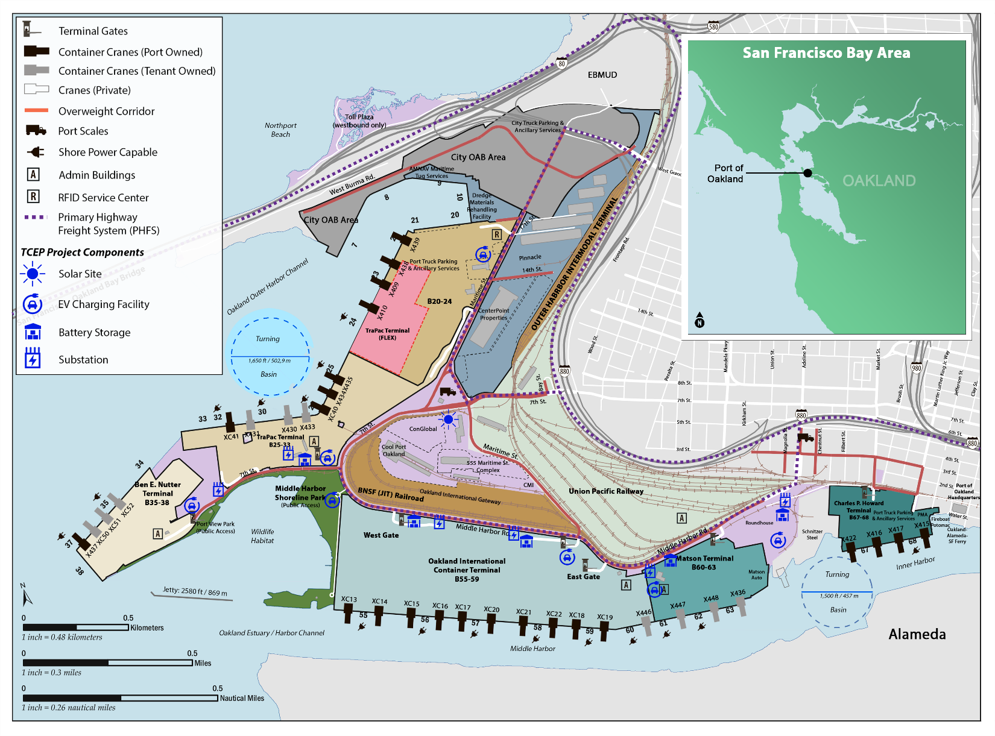
Figure FS.1 – Project Map

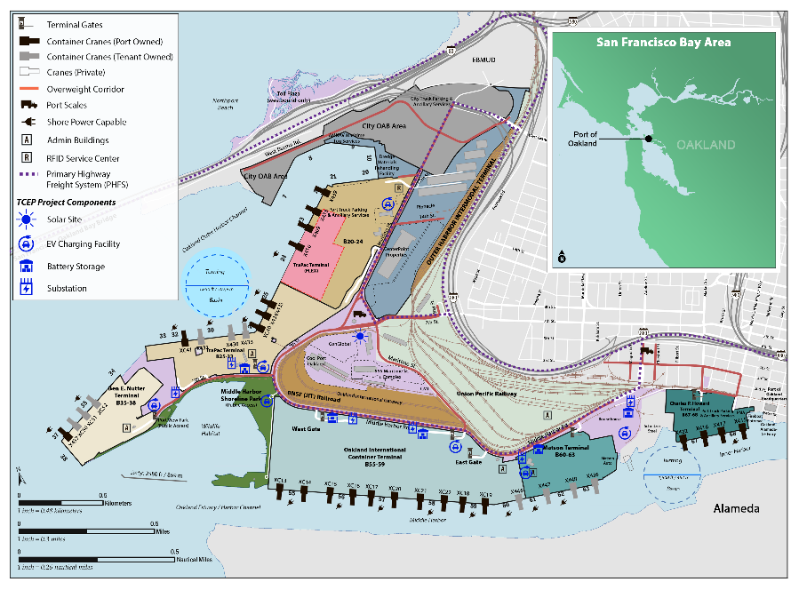
C.1 Project Overview

C. General Information

Project Title:
Green Power Microgrid

Project Description:
The Green Power Microgrid Project (Project) is a locally supported energy grid that would support Zero-Emission Vehicles (ZEV) including trucks and other zero-emission equipment at the Port of Oakland, the third-busiest container port complex in the State. The Project includes approximately one megawatt (MW) of solar power generation, battery energy storage systems (BESS) with a capacity of 6.5 MW, 145 heavy duty/Class 8 electrical vehicle chargers (expanding the ZEV charging capacity at the seaport to over 1000 pieces of equipment), enhancements to electric grid optimization, and substation upgrades at six locations (see Figure C.1.1). The Project would reduce emissions, toxic air pollutants, and noise pollution associated with goods movement in the vicinity of the Port (including in the neighboring disadvantaged community of West Oakland), increase the Port’s global competitiveness by introducing operational efficiencies (including the Port’s role as a primary and preferred export gateway for California agricultural goods), increase the Port’s resilience with increased and modernized power supply, storage and ability to withstand potential power outages, reduce accident risk by upgrading and modernizing electrical infrastructure, provide a back-up renewable energy source of shore power for ships berthed, and reduce congestion by limiting the need for offsite trips necessary only for refueling. Port electrification has been included in State, regional, local, community, and Port plans, demonstrating its alignment with local and regional interests and when complete, would support the State’s energy resilience, air quality, emissions, and climate change goals.
Figure C.1.1 – Project Map

Total Project Cost:
$59,477,250 (note that the total costs shown in Table H.1.1 are slightly different due to rounding)

Total Requested Amount:
$41,634,075 (note that the total costs shown in Table H.1.1 are slightly different due to rounding)

Project Background:
The Port’s plan for emissions reductions, Seaport Air Quality 2020 and Beyond Plan - The Pathway to Zero Emissions, was built upon the foundation established by the Maritime Air Quality Improvement Program (MAQIP) and looks ahead to address long-term planning for air quality, including the State’s greenhouse gas (GHG) emissions reductions targets, with extensive community and partner engagement. The Green Power Microgrid Project implements actions in the Intermediate-Term (2023-2030) Phase of the Plan. The Project will expand on and leverage the Port’s previous electrification efforts, such as the Zero And Near-Zero-Emission Freight Facility (ZANZEFF) program grant battery electric truck demonstration, Sustainable Terminals Accelerating Regional Transformation (START) project demonstration, California Air Resources Board (CARB) partnership demonstrations, fourteen Port funded existing electric charging stations and infrastructure upgrades, and the recent Port Infrastructure Development Program (PIDP) Powering the Future Project, which received federal funding in support of zero-emissions infrastructure from the United States Maritime Administration (MARAD). The PIDP project will support the Port’s expansion of an electric heavy-duty truck fleet and electrically-powered cargo-handling equipment by increasing power capacity and resiliency through modernization of a substation and integration of a fuel cell, solar power generation and battery storage systems.

Purpose and Need:
The adjacent communities to the Port experience some of the highest levels of pollution in the Bay Area according to the Bay Area Air Quality Management District (BAAQMD). These communities have been identified as a priority Assembly Bill (AB) 617 Community Health Protection Program area, and are included in the Metropolitan Transportation Commission’s (MTC) Equity Priority Communities effort representing census tracts that have a significant concentration of underserved populations, such as households with low incomes and people of color. The Port has been working together with the BAAQMD, West Oakland Environmental Indicators Project (WOEIP), California Air Resources Board (CARB), the freight community, and local community for over 15 years to improve air quality and support public health through major investments, innovation, and commitment, exceeding emissions reduction goals despite an increase in cargo volume. The Project improvements will help create a multi-functional and modern electrical grid, integrating local renewable power generation and storage to support expansion of electric operational infrastructure at the Port. The Project will also provide back-up power in case of outages or electricity utilization restriction events (e.g., heat waves) for vessels while at berth including cargo ships, non-container vessels, such as harbor craft (e.g., tugboats), and vessels in the federal defense fleet to help improve Port and community electrical grid resiliency. The solution also allows for grid connected refrigerated containers to support the export of more California agricultural goods. Providing these electrical infrastructure systems to support zero-emissions equipment and operations is essential to decarbonizing the Seaport and delivering related air quality, community health, and jobs benefits in support of State air quality and climate goals and investment targets.

C.2 Project Location
The Project is located in Alameda County in the San Francisco Bay Area (Caltrans District 4), within a Port complex, along the Primary Highway Freight System. Key roads serving the Port include Maritime Street, Middle Harbor Road, 7th Street, West Grand Avenue, Adeline Street, Interstate (I) 880 and I-80.

C.3 Project Priority
FOR HQ USE ONLY

C.4 Project Scope
The proposed Project would enable the Port to support a high number of electric vehicles, increase the renewable energy mix available to the Port and surrounding communities, increase the Port’s current ZEV capacity from 50 pieces of equipment to approximately 1,000 pieces of equipment, support grid optimization through load shifting and better demand management, support the local community by providing power during periods of excess solar generation, modernize onsite and local grid connections, provide back-up renewable shore power to vessels berthed at the Port, significantly increase the Port’s capacity to support grid-connected refrigerated containers, improve air quality and health outcomes in neighboring communities, and support critical climate objectives.
A list of outputs for the Green Power Microgrid include:
- Solar generation (1MW) and accompanying battery energy storage systems (6.5MW)
- 145 heavy duty/Class 8 electrical vehicle chargers distributed throughout the Port in support of yard, dockside, and transient vehicle use
- Enhanced electric grid optimization including investments to support demand response and load shifting to ensure a responsive green emergency power system, as the usage of the Port’s energy system is very dynamic by time of day and location
- Substation upgrades at six (6) locations across the Port
Figure C.4.1 – Solar Array, Battery Storage, and Electric Truck Charging Renderings
Figure C.4.2 – Project Map

C.5 Independent Utility
This Project has independent utility and does not involve segmentation. Construction of the Project is not contingent upon any other project.
In addition, the Port is unique among major container ports because it is also a public owned utility (POU). As such, the Port has the authority to purchase, distribute, and resell power under applicable State and federal laws, rather than being dependent on decisions made by major electric utilities and can optimize the distribution of such energy. Therefore, the Port has control to optimally build out the electrical infrastructure to support zero-emissions and provide excess sustainable energy to support surrounding communities. The Port's utilities are established and successful, delivering electrical power consisting of 70 percent renewable and an additional 13 percent carbon-free power content label in 2020, while keeping electric utility rates approximately 20 percent lower than surrounding investor-owned utilities, assisting in reducing costs to Port tenants, and ensuring benefits to the regional workforce.

C.6 Project Consistency with Regional Transportation Plan (RTP)/Sustainable Communities Strategy (SCS)
The Project is consistent with and strongly supports multiple strategies in Metropolitan Transportation Commission (MTC) and Association of Bay Area Governments’ (ABAG) Plan Bay Area 2050, adopted in 2021 (https://www.planbayarea.org/) including:
- EN3. Fund energy upgrades to enable carbon neutrality in all existing commercial and public buildings. This Project supports electrification and resilient power to not just the Port buildings, but also Port vehicles and other facilities. Additionally, excess electricity could be made available to the local communities in the event of wildfire power supply disruptions (PSPS events), and California Independent System Operator events due to shortage of electricity generation and capacity, among other threats.
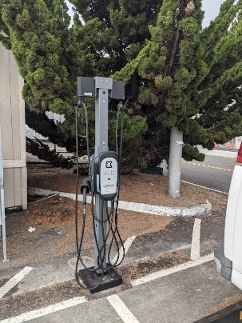
- EN8. Expand clean vehicle initiatives with investment in chargers.
- T2. Supporting community-led transportation enhancements in Equity Priority Communities. The Project supports multiple strategies in MTC’s Equity Priority Communities Framework, WOEIP (community-based organization) and BAAQMD’s Owning Our Air: The West Oakland Community Action Plan, 2019 including:
  - #18 Air District advocates for more electrical infrastructure and power storage, including truck charging stations
  - #19 Port of Oakland infrastructure plan to remove barriers to adoption of zero-emissions trucks, such as cost, land, and ownership of charging equipment
  - #29 CARB regulations to increase the number of zero-emission trucks and buses operating in West Oakland
  - #31 CARB amends transport refrigeration unit regulation to zero-emission technology and supporting infrastructure
  - #32 CARB amends cargo handling equipment regulation to zero-emission operation
  - #37 Port of Oakland supports transition to zero-emissions drayage truck operations
  - #43 Port of Oakland off-terminal container yard that uses zero-emission trucks to move containers to/from terminals
In addition, Plan Bay Area 2050 Project 21-T07-055, Minor Freight Improvements Regional, includes $2.5 billion in funding to implement freight improvements including programs/projects at the Port.
The Project is also included and supports the goals outlined in multiple other State, regional, local, community, and Port plans or programs as described in Section F.4.5.

C.7 Nominating Agency/Implementing Agency Agreement
This is a joint nomination between the Port, Caltrans and MTC. The Port will be the implementing agency.

D.1 Project Eligibility

D. Screening Criteria
The Green Power Microgrid Project meets the eligibility requirements for the TCEP and supports the goals of the National Highway Freight Program (NHFP), the California Freight Mobility Plan (CFMP), and the California Sustainable Freight Action Plan (CSFAP) as described in Table D.1.1.
Table D.1.1 – Project Eligibility
Eligible Project Type | Description | Alignment with NHFP, CFMP, CSFAP
Enhance the capacity and efficiency of ports | Locating ZEV charging stations throughout the Port complex area and within the terminals themselves may result in reduced vehicle-miles traveled (VMT) in the area from eliminating the need for the trucks to travel to fueling stations. | ZEV charging within the Port will reduce unnecessary trips associated with refueling, which would support objectives of the National Highway Freight Program (NHFP) and improve efficient movement of freight on the NHFN.  The Project supports the first goal under the CFMP to maintain, enhance and modernize the multimodal freight transportation system.
Freight infrastructure that enables zero-emission or near-zero emission goods movement | The Project supports increased use of zero-emissions vehicles (ZEV), equipment, and trucks accessing the Port via PHFS routes as a result of ZEV charging stations, BESS, and other infrastructure improvements. | The Project is consistent with eligible activities listed in the NHFP including: 4. Efforts to reduce the environmental impacts of freight movement and 5. Environmental and community mitigation for freight movement.  The Project strongly supports the 2020 CFMP to support environmental stewardship and healthy communities by reducing emissions and associated negative health impacts.  The ZEV charging stations and supporting infrastructure supports the transition to ZEV trucks and other freight vehicles under the CSFAP.
Environmental/ community mitigation | The Project would result in emissions and noise reduction related benefits to the Port area and adjacent disadvantaged communities in West Oakland. | The Project is consistent with eligible activities listed in the NHFP including: 4. Efforts to reduce the environmental impacts of freight movement and 5. Environmental and community mitigation for freight movement.  The Project strongly supports the CFMP to support environmental stewardship and healthy communities and the CSFAP by reducing toxics and GHG emissions to benefit disadvantaged communities by reducing emissions and associated negative health impacts.
Freight infrastructure related advanced technology | The Project will deploy a minimum of 145 electric vehicle chargers, and supporting infrastructure (e.g., BESS), which are considered advanced technologies. | The Project is consistent with eligible activities listed in the NHFP including: 3. Intelligent transportation systems and other technology to improve the flow of freight, including intelligent freight transportation systems and 21. Enhancement of the resiliency of critical highway infrastructure, including highway infrastructure that supports national energy security, to improve the flow of freight.  The Project supports the 2020 CFMP goals to maintain and preserve infrastructure assets and to maintain, enhance and modernize the multimodal freight transportation system.

E.1 Delivery Method

E. Project Delivery
As part of the initial Project planning and feasibility, the Port will evaluate multiple project delivery mechanisms, including traditional design-bid-build and design-build. Evaluation of such findings will guide the Port in its decision-making as it relates to the optimal project delivery with consideration of grant requirements, cost, schedule, and impacts to Port operations and resources.

E.2 Contracts
The preliminary planning and feasibility assessments undertaken as part of E.1 above will inform the number of contracts executed to realize Project implementation. The Port anticipates that more than one contract will be executed, and that similar and supporting project elements will be bundled by substations/BESS, solar, and ZEV charging.

E.3 Schedule Risks
The Port has extensive experience working with the State and other entities to deliver projects. The funds can easily be obligated and expended within the timeframes desired by the State, and potential Project risks are low as indicated in Table E.3.1.
Table E.3.1 – Schedule Risks
Potential Schedule Risks | Proposed Mitigation Strategies
Approvals from third-party entities – Low | Most of the proposed Project improvements will be undertaken within Port property and approvals will not be necessary.  In addition, the Port is a public owned utility (POU) with the authority to purchase, distribute, and resell power under applicable State and federal laws, rather than being dependent on decisions made by major electric utilities.
Variability in the supply chain for procurement of needed equipment - Low | It is premature to assume supply chain impacts given the multi-year timeline for Project.
Right-of-way – Low/None | All work will be carried out on Port property.
Environmental review- Low | The Project area has been extensively studied in past CEQA and NEPA analyses.
Permitting - Low | Distribution facilities would be greater than 50 kilovolts (kV), and would need to be permitted by CPUC. The Port will conduct regular coordination meetings to ensure that the schedule remains on track.

E.4 Railroad Company Coordination
Coordination with rail companies will not be required for the Project.

E.5 California Environmental Quality Act (CEQA)/National Environmental Policy Act Status
The Port is the Lead Agency under the California Environmental Quality Act (CEQA), having land use jurisdiction over the proposed Project site. Similar electrification projects at the Port have been assigned a categorical exemption pursuant to CEQA guidelines. Project implementation is not expected to result in adverse impacts to adjacent communities and no right-of-way approvals are expected. The Port will review the Proposed Project description to determine the appropriate level of CEQA documentation and any potential environmental impacts from the proposed Project. The environmental review process for the proposed Project is estimated to be completed by 2023 and construction could begin within 18 months of funding being encumbered. NEPA does not apply as there are no Federal nexus (i.e., funding, federal regulatory permitting, etc.) being used for the proposed Project.

The following provides the anticipated quantitative and qualitative benefits for the Green Power Microgrid Project.

F.1 Freight System Factors

F. Evaluation Criteria

F.1.1 Throughput
The Project is anticipated to reduce VMT for trucks about to utilize charging facilities at the Port rather than traveling to refuel at nearby diesel/gas facilities which could result in improved cargo throughput. However, no data is available to quantitatively support this benefit.

F.1.2 Velocity
This Project is not anticipated to have velocity related impacts.

F.1.3 Reliability
While the Project does not impact truck travel time reliability, it does improve supply chain resiliency and reliability for the Port through improvements to the electrical grid and ZEV charging capability. Overall reliability of Port operations could be maintained, including security functions, in the case of potential power failures or shutdowns.

F.2 Transportation System Factors

F.2.1 Safety
While the Project does not reduce vehicular crashes, the Project does improve community and Port-operational safety concerns by:
- Reducing harmful emissions associated with negative health impacts for workers at the Port and neighboring communities. Over 90 percent of the cancer risk from local air pollution in West Oakland is attributable to diesel particulate matter. Residents also experience higher rates of deaths from cancer, heart disease, and strokes, and higher rates of asthma emergency room visits and hospitalizations. Producing energy from renewable sources reduces air pollution and other health burdens associated with fossil-fuel-based electrical power. The Project supports increased use of ZEV/equipment, reducing diesel-related emissions related deaths and other health impacts.
- Reducing worker exposure to accidents through replacement of end-of-life electrical infrastructure, as well as workforce development training to ensure safe access, maintenance, and operational practices associated with the new Project equipment.
- Improvements in noise reduction help vehicles operating on the Port to reach compliance with the Federal Motor Carrier Safety Administration and EPA noise emission standards. Reducing traffic-related noise can help reduce health risk of hearing loss and developmental delay associated with repeated exposure to noise. It can also reduce noise experience for Port workers and truck drivers, improving the work environment, and lessening driver fatigue.
- Excess power could be used as short-term emergency power supply for neighboring communities, reducing potential deaths from heat-stroke or loss of life-supporting electric-powered medical equipment.

F.2.2 Congestion Reduction/Mitigation
The Project enables a shift from carbon-based fuels with adverse global and localized impacts to Port workers and the disadvantaged community of West Oakland, to renewable solar electricity to power vehicles at the Port, operational infrastructure, refrigerated containers, and other facilities. Though not a modal shift, it provides emissions and fuel use reductions on par with modal-shift projects and is consistent with statewide goals and the Climate Action Plan for Transportation Infrastructure (CAPTI) investment framework, most notably including investments in ZEV infrastructure and developing a zero-emission freight transportation system.
The Project is also anticipated to reduce VMT as trucks will be able to charge at the Port rather than refueling at nearby facilities, therefore reducing congestion associated with the refueling trips. However, no data is available to quantitatively support this benefit.
Table F.2.1 – Congestion Reduction Performance Measures
Measure | Metric | Project Type | Build | Future No Build | Change | Increase/  Decrease
Congestion Reduction (Freight) | (Optional) Truck Miles Shifted from Diesel-Based VMT to Electric-Powered VMT for Trucks Utilizing ZEV Chargers | All | 0 Diesel-Based Truck Miles (20-year total) | 344,790,370 Diesel-Based Truck Miles (20-year total) | 344,790,370 Diesel-Based Truck Miles (20-year total) | Decrease

F.2.3 Key Transportation Bottleneck Relief
The Project is also anticipated to reduce VMT as trucks will be able to charge at the Port rather than refueling at nearby facilities, which could provide bottleneck relief. However, no data is available to quantitatively support this benefit.

F.2.4 Multi-Modal Strategy
The Project supports reductions in diesel-based VMT (reducing GHG emissions and other pollutants) for yard and drayage tractors by going electric. Additionally, charging stations made available to electric drayage trucks visiting the Port would also significantly reduce diesel-based VMT and idling. The result is a significant reduction in emissions, on par with environmental and public health benefits, when compared to a standard VMT reduction project. In addition, locating ZEV charging stations throughout the Port complex area, and within the terminals, may result in reduced VMT in the area from eliminating the need for trucks to travel to fueling stations. Additionally, charging stations could be made available to transit vehicles or other private or public vehicles.

F.2.5 Interregional Benefits
The Project will serve interregional, statewide, national, and international trade corridor needs by providing the necessary equipment and infrastructure to support ZEV at the Port. The Port is the third-busiest container port complex in the State, and brought in more than 1.9 million twenty-foot equivalent units (TEU) in 2021. In addition, the Project could provide power to support the transport of mostly agricultural export cold storage freight cargo, which is critical to the economy as Northern California is the second largest exporting region in the U.S. The Project is also anticipated to provide reliability and resiliency at the Port when during PG&E shutdown events or when requested by the State to reduce power demand. This Project also supports President Biden’s Executive Order on America’s Supply Chain and Executive Order 14008 on Tackling the Climate Crisis at Home and Abroad by strengthening and developing a more resilient supply chain.

F.2.6 Advanced Technology
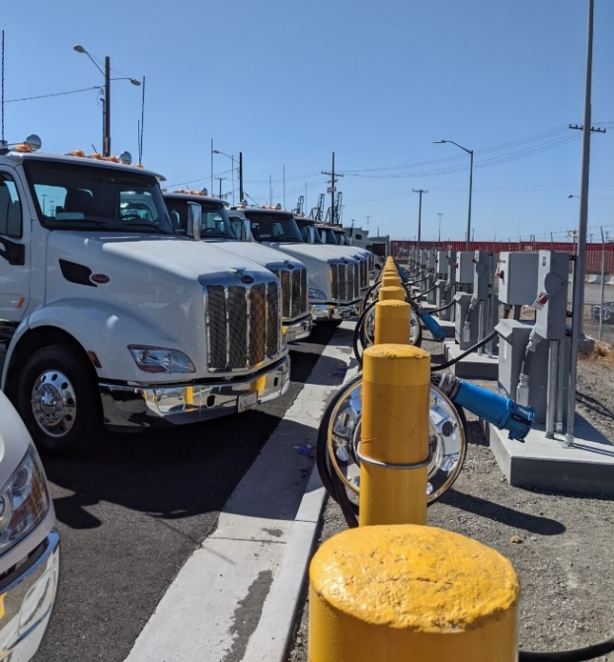
The Green Power Microgrid Project will deploy multiple advanced technology components including ZEV charging stations and BESS and the necessary infrastructure to support zero-emissions, along with innovative grid optimization technology such as peak demand management, storage of green power energy, substations that can carry loads to and from the grid, and providing reliability and resiliency through secondary and redundant feeds insulating and protecting the Port from external electric power reliability. The Project will reduce noise and emissions generated by trucks at and near the Port and associated impacts on the adjacent disadvantaged communities. In addition, it will help the State in delivering air quality, community health, and jobs benefits in support of State air quality and climate goals and investment targets.

F.2.7 Zero-Emission Infrastructure
The Project is explicitly designed to provide support for ZEVs and includes ZEV infrastructure. Specific zero-emission infrastructure is described in C.4 Project Scope and includes:
- 145 heavy duty/Class 8 electrical vehicle chargers distributed throughout the Port in support of yard, dockside, and transient vehicle use.
- Supporting infrastructure such as solar generation, battery storage systems, and upgrades to substations and supporting distribution components of the Port’s electrical grid.
Vehicles that use the charging stations would include vehicles with a zero-emissions powertrain that produces zero exhaust emission of any criteria pollutant or GHGs under any possible operational mode or conditions. The vehicles served by this infrastructure primarily include medium- and heavy-duty vehicles used for freight, and can support over 1,000 additional cargo equipment units, depending on energy needed and utilization.
The Project will enable support of electric operational infrastructure and provide charging capacity for drayage trucks visiting the Port while potentially making surplus power and chargers available to local transit agency vehicles and/or other public and private ZEVs. In addition, the Project can provide back-up electric power for vessels while at berth in the event of power outages or electricity use restrictions.
The Project builds towards a zero-emissions freight transportation system that supports the State’s air quality and climate targets with the following benefits:
- Reductions in emissions of GHG, criteria pollutants such as particulate matter, and noise for the Port area and neighboring disadvantaged communities through increased use of electric vehicles and equipment
- Health benefits from producing energy from renewable sources
- Reductions in maintenance and operating expenses associated with more reliable electric-powered equipment and infrastructure
- Resiliency in the form of reductions in lost labor productivity, and potential use for refrigerated or frozen cargoes, due to power loss or limitations
- Safety through reduced accident risk from upgrades and modernization of electrical infrastructure
The Project does not include the purchase of automated cargo equipment. The majority of ZEV charging equipment will be publicly accessible.
The Port confirms that all contractors responsible for installing the infrastructure shall be licensed with an A, B, or C-10 classification, and have or will participate in Apprenticeship programs approved by the State of California, Division of Apprenticeship Standards that have a proven track record of annually graduated persons from California Climate Investments Priority Populations.
This Project incorporates significant public engagement with the historically disadvantaged West Oakland community adjacent to the Port, as well as other Port stakeholders and agencies. Community engagement information can be found in Section F.3.3.

F.3 Community Impact Factors

F.3.1 Air Quality Impact
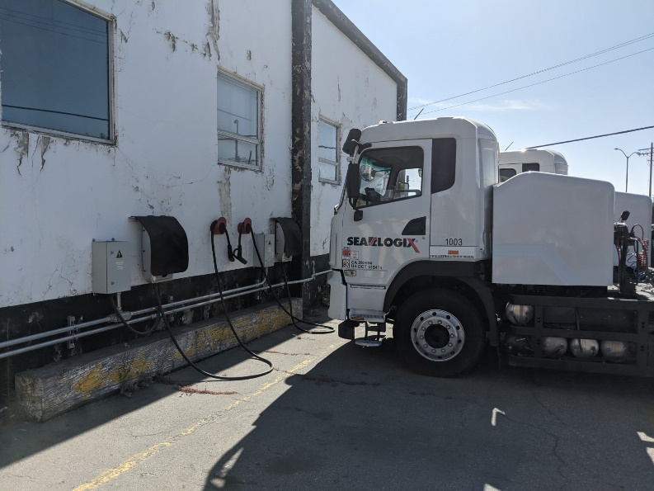
This Project would enable the Port to provide reliable power to allow for ZEVs, including trucks and other zero-emissions equipment, to be charged at the Port. The primary public benefit from these improvements is reduced emissions from charging electric yard tractors and drayage trucks that would replace diesel units. Yard tractors are used to move containers and chassis within the marine container terminals. According to the Port of Oakland 2020 Seaport Air Emissions Inventory (2021), there are 235 diesel yard tractors at the Port. The improvements to the substations and installation of 145 charging stations could support all of the yard tractors. Most of the terminal yard tractors operated on average about 1,600 hours annually in short-trip, idling, and stop-start service that produced relatively high emissions (0.25 tons of NO_{X}, 0.005 tons of PM₁₀, and 87.48 tons of CO₂ annually per tractor based on the Port’s emissions inventory). According to the Port of Oakland, Seaport Air Quality 2020 and Beyond Plan (2019), approximately 70 yard tractors would be using electric power versus diesel or gasoline when this Project is fully operational in 2027 and the analysis assumes the full 235 diesel yard tractors would be electric by 2035, consistent with State Executive Order N-79-20 goals.
Drayage trucks move containers or bare chassis over public roads and in/out of terminals and can range from less than a mile within the Port area or hundreds of miles. Near Port truck utilization was assumed for the analysis. This Project could support approximately 900 additional drayage trucks, likely significantly more when the chargers are upgraded in 2035, though the actual number would be dependent on the duration and timing of tractor charging. The emissions analysis utilized Port of Oakland drayage truck emission factors from the 2020 Seaport Air Emissions Inventory (2021) and consisted of four elements of the local or short-haul drayage truck travel: 1) within the terminals operating at 13.5 mph on average, 2) outside of the terminal operating at 29 mph on average, 3) average terminal gate idling time, and 4) average in terminal idling time. The approach conservatively assumed an average of two trucks would utilize the ZEV chargers located outside the terminals daily when open in 2027 and eight per day in 2035. This equates to 150 trucks per day in 2027 to 600 in 2035. The chargers would be replaced starting in 2035 allowing greater utilization (1200 trucks daily).
The emissions and diesel fuel use reduction from this shift from diesel-based VMT to electric vehicle utilization would result in significant emissions benefits to the Port area and adjacent and nearby disadvantaged communities as summarized in Table F.3.1. The emissions savings are estimated to be $162.8 million ($81.9 million discounted) over the 20-year analysis period. Details regarding the emissions analysis can be found in Appendix B, the Benefit/Cost Analysis Spreadsheet, and Benefit/Cost Analysis Methodology Report.
Table F.3.1 – Air Quality and Greenhouse Gases Performance Measures
Measure | Metric | Project Type | Build | Future No Build | Change | Increase/  Decrease
Air Quality and Greenhouse Gases | Particulate Matter (PM 10) | All | Tons: 0 | Tons: 94 | Tons: 94 | Decrease
 | Particulate Matter (PM 2.5) |  | Tons: 0 | Tons: 48 | Tons: 48 | Decrease
 | Carbon Dioxide (CO2) |  | Tons: 0 | Tons: 1,102,208 | Tons: 1,102,208 | Decrease
 | Volatile Organic Compounds (VOC) |  | Tons: 0 | Tons: 379 | Tons: 379 | Decrease
 | Sulphur Oxides (SOx) |  | Tons: 0 | Tons: 10.4 | Tons: 10.4 | Decrease
 | Carbon Monoxide (CO) |  | Tons: 0 | Tons: 1,404 | Tons: 1,404 | Decrease
 | Nitrogen Oxides (NOx) |  | Tons: 0 | Tons: 3,465 | Tons: 3,465 | Decrease

F.3.2 Economic Impact
Based on The Economic Impact of the Port of Oakland report by Martin Associates (2018), the total economic value of marine cargo and vessel activity at the Port is estimated at $60.3 billion; supporting approximately 500,000 jobs in the State of California, including 11,393 jobs directly created by Port activities, as well as more than 16,000 induced and indirect jobs. Modernizing the electrical grid and systems and installing heavy-duty electric vehicle chargers at the Port is essential to supporting the economic vitality at the local, regional, and State levels, as well as the national level to handle future growth, as well as provide the necessary infrastructure to support the State’s climate change and resiliency goals.
Based on the total project cost of $59,477,250, and the factor provided in the performance measure guidance based on the Federal Highway Employment Impacts of Highway Infrastructure Investment (0.000013 jobs for each dollar), there would be approximately 773 jobs created. The Port estimates that once the Project is operational, two 0.5 Full-Time Equivalent (FTE) staff will be needed to operate and maintain the Project components, one for facilities and one an engineer.
Since electrification projects are not available for analysis within Cal-B/C, the benefit/cost analysis (BCA) involved the development of a transparent spreadsheet tool to calculate the benefit/cost ratio for the purposes of this application. Most of the parameters and monetization values are consistent with Cal-B/C. The Benefit/Cost Analysis Spreadsheet and Benefit/Cost Analysis Methodology Report are provided as attachments detailing the analysis assumptions, parameters, approach, and calculations.
In addition to the emissions benefits described in Section F.3.1, the solar array component of the Project has non-emissions health benefits from reductions in fossil fuel-based generation. The Project is estimated to result in over $208,000 in discounted public health benefits over the 20-year analysis ($360,000 nominal). The Project has an estimated benefit/cost ratio of 1.6 (2.7 nominal) with net benefits of $29 million over the 20-year analysis when discounted at 4% in 2021 dollars. Table F.3.2 presents the expected monetary benefits for electric charging emissions, public health savings, residual value for assets with a useful life greater than the 20-year analysis period, maintenance and operating costs and capital costs.
Table F.3.2 – Benefit/Cost Summary
Benefits and Costs | Discounted Value  (2021 dollars) | Nominal Value
EV Chargers Emissions Reductions | $81,914,810 | $162,770,897
Solar Array Public Health Savings | $208,065 | $360,189
Maintenance & Operations Costs | $(8,877,177) | $(17,257,000)
Residual Asset Life | $5,007,434 | $13,349,000
Total Benefits | $78,253,132 | $159,223,086
Total Costs | $49,209,817 | $59,477,250
Benefit/Cost Ratio | 1.6 | 2.7
NPV= | $29,043,316 | $99,745,836

Table F.3.3 – Economic Development and Cost Effectiveness Performance Measures
Measure | Metric | Project Type | Build | Future No Build | Change | Increase/  Decrease
Economic Development | Jobs Created | All | 773 | 0 | 773 | Increase
Cost Effectiveness | Cost-Benefit Ratio | All | 2.7 nominal,  1.6 discounted | N/A | 2.7 nominal,  1.6 discounted | NA

F.3.3 Community Engagement
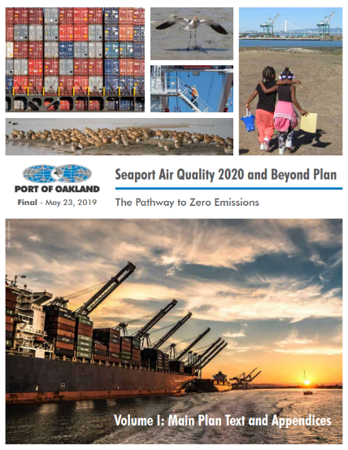
The Port has conducted extensive public engagement to incorporate neighboring West Oakland community needs into the Project and continues to work with local community members, businesses, and a multitude of stakeholders via public information meetings, consultations, social media outreach, Task Force meetings, and other forms of stakeholder engagement. West Oakland, adjacent to the Port, is considered an environmental justice community and is designated by CARB under Assembly Bill 617 as a community bearing a disproportionate air quality burden. The Port’s Seaport Air Quality 2020 and Beyond Plan's Public Engagement Plan (2019) involved the preparation of a community profile using 2017 census data. Approximately 76 percent of the West Oakland population consists of people of color, and 27 percent live below federal poverty levels.
Throughout the development of the 2020 and Beyond Plan, the community has been clear in its desire to see a complete changeover to zero-emissions trucks and cargo-handling equipment for Port-related activities and has requested the Port to take a leadership role in developing the infrastructure necessary to enable the transition to zero-emissions and reduce diesel particulate matter (DPM) emissions from Port operations. The local community has also expressed its desire to see generation of power from renewable resources in the Port area to ensure more resilient and clean energy operations in the event of power disruptions occurring outside of the Port’s jurisdiction. Public engagement activities were performed during the development of the plan and engagement will continue through all implementation phases. The Project fulfills several of the implementing actions included in the 2020 and Beyond Plan. Details can be found in the Plan’s Appendix G Public Engagement Plan.
In addition to its direct engagement with stakeholders in the community, the Port of Oakland implements best practices to ensure its activities are fully compliant with Title VI of the Civil Rights Act of 1964 and other equal access laws. The Port of Oakland’s outreach strategies include, but are not limited to:
- Reasonable public access to technical and policy information
- Adequate public notice of public involvement activities and time for public review and comment at key decision points
- Concerted efforts to involve the public, especially those traditionally underserved by existing programs or plans including but not limited to low-income and minority households
- Coordination of planning processes, especially where multiple levels of oversight exist, public processes to enhance public consideration of the issues, plans and programs and reduce redundancies and cost
- Ensure opportunity for full participation of Limited English Proficiency (LEP) speakers through provision of language interpretation services
- Ensure opportunity of full participation of persons with disabilities by providing reasonable accommodations
The Port has also collaborated with the local community and the City of Oakland with public engagement activities to prepare two truck management plans for truck travel and parking, including the West Oakland Community Action Plan (WOCAP). The Project supports strategies in the WOCAP including charging equipment, transition to zero-emissions drayage truck operations, and investing in upgrades to the Port’s electrical infrastructure to support the above stated goals.

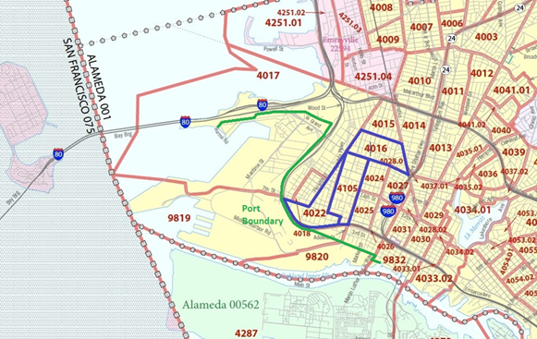
Disadvantaged or Historically Impacted and Marginalized Communities
Figure F3.3.1 – Median Household Income

The Project is located within or directly adjacent to several disadvantaged or historically impacted and marginalized community types including:
- Median Household Income (Figure F3.3.1) – Census tracts at less than 80% of the statewide median (<$56,982) include #4016 ($53,750), #4105 ($24,318), and #4022 ($56,615)
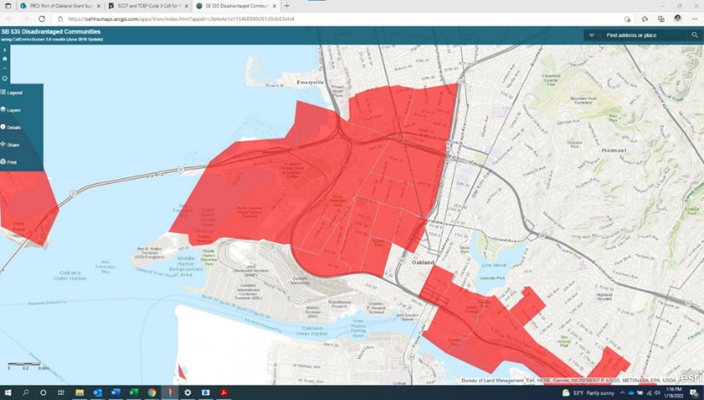
- SB 535 Disadvantaged Community – Portions of the Port, as well as the neighboring West Oakland community meet the criteria of most disadvantaged 25% in the State according to the CalEPA and the CalEnviroScreen score (Figure F3.3.2)
Figure F3.3.2 – SB 535 Disadvantaged Community, CalEnviroScreen
- National School Lunch Program - All seven Oakland Unified School District schools within the West Oakland Community qualify as a disadvantaged community under the National School Lunch Program with eligibility ranging from 85-95%, well above the 75% criteria, and all are less than 2 miles from the Port of Oakland. See Figure F3.3.3.
- Healthy Places Index – Multiple census tracts in the adjacent West Oakland Community qualify (see Figure F3.3.4).
- Equity Priority Communities as defined in the MTC Plan Bay Area 2050 which focuses on people of color and low-income (see Figure F3.3.5).
The Project will directly reduce Port and truck-related emissions impacts within the Port and adjacent disadvantaged communities.
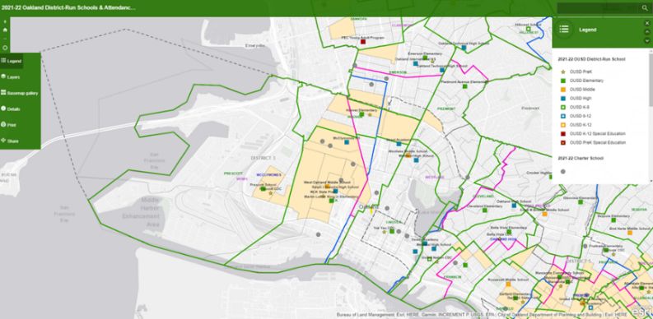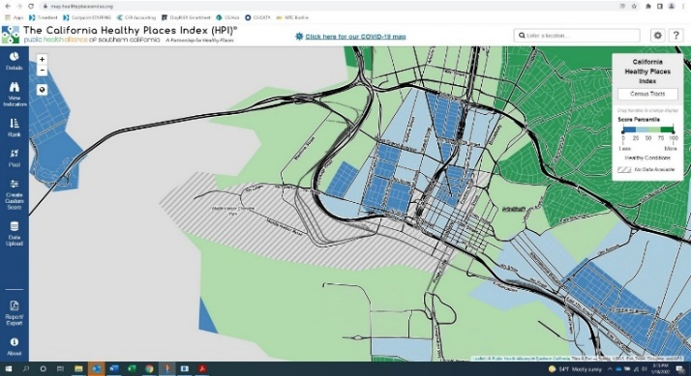
Figure F3.3.4 – California Healthy Places Index Map
Figure F3.3.3 – National School Lunch Program Disadvantaged Communities
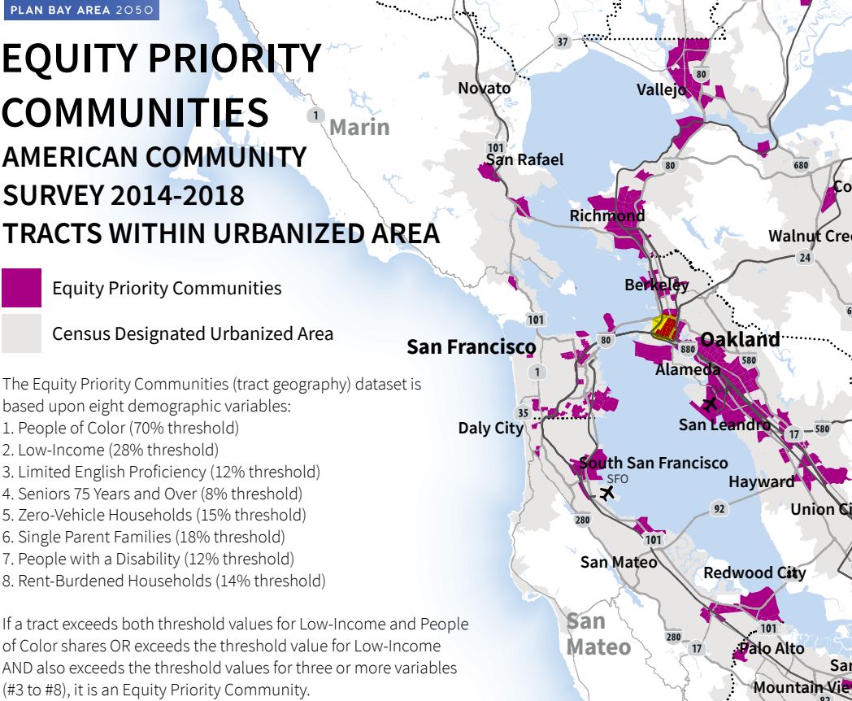
Figure F3.3.5 – MTC Equity Priority Communities

Addressing Community Needs
The Green Power Microgrid Project would reduce freight emissions and toxic air pollutant impacts on the neighboring disadvantaged community of West Oakland, most of which is dark purple in the Heatmap layer in the Governor's Office of Planning, and Research's Site Check. This reduction in air pollutant impacts will improve community walkability and bike-ability and provides access to a publicly accessible ZEV charging location within the Middle Harbor Shoreline Park, providing opportunity and potentially reducing transportation cost burdens to the community. Lastly, the Project will not displace residents or businesses.

F.4 Other Criteria

F.4.1 Urgent Freight Needs
The Green Power Microgrid provides the electrical infrastructure systems to support zero-emissions equipment and operations which is essential to decarbonizing the Seaport and delivering related air quality, community health, and jobs benefits in support of State air quality and climate goals and investment targets. This supports State Executive Order N-79-20, which directs the State Transportation Agency, the Department of Transportation and the California Transportation Commission to identify near term actions, and investment strategies, to improve clean transportation and sustainable freight. It includes a goal that 100 percent of medium- and heavy-duty vehicles in the State be zero-emission by 2045 for all operations where feasible and by 2035 for drayage trucks.
The Project improves the supply resiliency and reliability of the Port of Oakland through improvements to the electrical grid and ZEV charging capability in the seaport. The Project reduces the possibility of power failure hindering Port operations and the State’s supply chain. The on-site generation and storage will enable the Port to maintain a basic level of operations, including security functions, during power outages. Additionally, the Project will provide adequate power to support the transport of cold storage freight cargo, predominantly composed of agricultural export cargo, which is critical to the economy as Northern California is the second largest exporting region in the U.S. This Project supports President Biden’s Executive Order on America’s Supply Chain and Executive Order 14008 on Tackling the Climate Crisis at Home and Abroad by strengthening and developing a more resilient supply chain.

F.4.2 Leveraging Funds
Receiving the grant funds would enable the Port to accelerate its transition to a zero-emissions seaport by upgrading its infrastructure. Private sector parties have approached the Port to express their interest in developing electric charging infrastructure and deployment of zero-emissions trucks at the Port. With multiple electric drayage tractors in local service and more on order, regional drayage operators have demonstrated their interest and commitment to a zero-emissions future. Without assurance of grid capacity and charging infrastructure, however, their commitment cannot yield the emissions reductions to help achieve the state’s goals and environmental justice demands. The Port has committed an $18 million local match for implementation of this Project.

F.4.3 Project Readiness
Environmental clearance for the Project is estimated in 2023, within 6 months of TCEP adoption, and construction could begin within 18 months of funding being encumbered. The Green Power Microgrid Project will expand on and leverage the Port’s previous electrification efforts, such as the Zero And Near-Zero-Emission Freight Facility (ZANZEFF) program grant battery electric truck demonstration, Sustainable Terminals Accelerating Regional Transformation (START) project demonstration, California Air Resources Board (CARB) partnership demonstrations, fourteen Port funded existing electric charging stations and infrastructure upgrades, and the recent PIDP Powering the Future Project, which received federal funding in support of zero-emissions infrastructure from MARAD. The PIDP project will support the Port’s expansion of an electric heavy-duty truck fleet and electrically-powered cargo-handling equipment by increasing power capacity and resiliency through modernization of a substation and integration of a fuel cell, solar power generation and battery storage systems. NEPA evaluation and approval are not anticipated for the Project (see Section E.5), and CEQA is anticipated to result in categorical exemptions. Further, given that the proposed improvements are location within Port property and operations, agreements with third-parties are not anticipated.

F.4.4 Project Delivery Commitment
The Port is a financially sound organization with a stable revenue base and a firm financial standing. The Port’s liquidity position, comprised of both unrestricted cash and Board reserves, remains strong and provides the Port the financial flexibility to adapt and respond to COVID-19 and other future operational and financial challenges. In September 2022, Moody’s Investors Service affirmed the Port’s A+ and A credit ratings reflecting the Port's strong financial flexibility, robust liquidity, comfortable debt service coverage, manageable capital spending and significant long-term debt capacity. Moody’s says the Port of Oakland has sufficient liquidity to manage potential near-term challenges. Furthermore, Port operations are supported by a strong and diverse local economy. The Bay Area continues to be an important center of commerce, and the Port remains an important, key gateway for both domestic and international trade and a top travel destination.
The Port is unique among major container ports because it is also a public owned utility (POU). As such, the Port has the authority to purchase, distribute, and resell power under applicable State and federal laws, rather than being dependent on decisions made by major electric utilities and can optimize the distribution of such energy. Therefore, the Port has control to optimally build out the electrical infrastructure to support zero-emissions and provide excess sustainable energy to support surrounding communities. The Port's utilities are established and successful, delivering electrical power consisting of 70 percent renewable and an additional 13 percent carbon-free power content label in 2020, while keeping electric utility rates approximately 20 percent lower than surrounding investor-owned utilities, assisting in reducing costs to Port tenants and ensuring benefits to the regional workforce.
Caltrans and MTC are joint partners on this Project and have partnered with the Port on prior projects successfully.

F.4.5 Other Factors
The letters of support for this TCEP grant can be viewed in Appendix E.
The Green Power Microgrid Project is included and supports the goals outlined in multiple State, regional, local, community, and Port of Oakland plans or programs demonstrating support for the Project such as:
- CalSTA and Caltrans, California Freight Mobility Plan 2020 (2020)
- CalSTA, Climate Action Plan for Transportation Infrastructure (2021)
- CalSTA, California Environmental Protection Agency, Natural Resources Agency, California Air Resources Board, Caltrans, California Energy Commission, and Governor’s Office of Business and Economic Development, California Sustainable Freight Action Plan (2016)
- MTC, San Francisco Bay Area Goods Movement Plan (2016)
- MTC and ABAG, Plan Bay Area 2050 (2021)
- BAAQMD, AB 617 Community Health Protection Program and the West Oakland Environmental Indicators Project and BAAQMD, Owning Our Air: The West Oakland Community Action Plan (2019)
- BAAQMD, 2017 Clean Air Plan - Spare the Air Cool the Climate, A Blueprint for Clean Air and Climate Protection in the Bay Area (2017)
- Alameda County Transportation Commission (Alameda CTC), Alameda County Goods Movement Plan (2016)
- Alameda CTC, Countywide Transportation Plan (2020)
- City of Oakland, 2030 Equitable Climate Action Plan (ECAP), (2020)
- Port of Oakland, Seaport Air Quality 2020 and Beyond Plan – The Pathway to Zero Emissions (2019)
The Project also supports the SB 671 Clean Freight Corridor Efficiency Assessment nomination of I-80 and I-880 by the Port of Oakland, Alameda CTC, Solano Transportation Authority, Contra Costa Transportation Authority, and MTC, which connect the Port of Oakland with warehousing and distribution hubs, manufacturing facilities, and agriculture. There is strong support from local jurisdictions, elected officials, and the private sector throughout the region to advance zero-emissions technologies along the two major freight corridors serving the Northern California Megaregion and the Port of Oakland.
Lastly, the Port consistently reviews its policies and strategies to ensure local communities have access to opportunities provided by Port projects, supporting racial equity and reducing barriers to opportunities for neighboring disadvantaged communities. Port initiatives and staff specifically monitor and address:
- Compliance with State and federal wage rate requirements.
- Employment and equal opportunity complaints.
- Job creation (especially for economically distressed areas).
- Local hours and apprenticeship goals.
- Environmental health, safety, and justice concerns (especially as they affect traditionally marginalized communities).
- Port’s Living Wage Policy: The Port living wage is an hourly wage level adopted by some local governments that set wages at a higher level than the local, federal and/or state minimum wage.
- Port’s MAPLA (Maritime and Aviation Project Labor Agreement): MAPLA is an agreement between the Port of Oakland and the Alameda Building and Construction Trades Council that promotes project stability, construction efficiency and local hiring opportunities on all Port projects over $150,000 that are a part of the Port’s Capital Improvement Plan (CIP). Contractors are required to pay $0.30 per work hour into a Social Justice Trust Fund that is used to support local workforce development programs.
- Port’s Operations Jobs Policy tenets: (Fair Chance hiring, local hiring preferences/focus on disadvantaged workers and temporary worker protections). In 2017, the Port of Oakland Commissioners passed an Operations Jobs Policy for the Seaport Logistics Complex with CenterPoint Logistics, Inc. Key aspects of this jobs agreement include living wages and benefits for workers, priority consideration for unemployed individuals, armed forces veterans, single parents, ex-offenders, and foster care adults; and a ban on asking applicants about prior criminal offenses.
- Local, small, and disadvantaged business utilization policies: The Port has bid preferences and goals for including local, small and disadvantaged businesses on Port projects.

G.1 Accessibility

G. Other Project Information Areas
Not applicable.

G.2 Climate Change Resilience and Adaptation
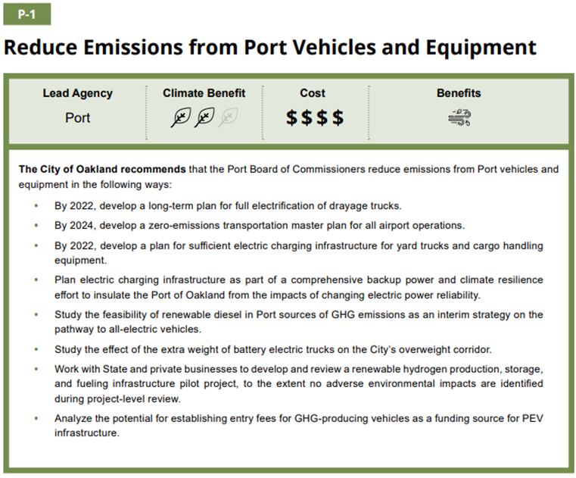
The Green Power Microgrid Project directly improves climate adaptation and resiliency identified in regional and local climate change adaptation plans. The City of Oakland 2030 Equitable Climate Action Plan (ECAP) (2020) builds on nearly three decades of progressive, science-based policies and programs that the City has pursued to reduce climate impacts and reverse environmental harms. The Project implements the Port actions in the ECAP: P-1 Reduce Emissions from Port Vehicles and Equipment and P-2 Reduce Emissions from Electricity. The Project will support electrification of drayage trucks and other Port vehicles and operational infrastructure with electric charging, generation, storage infrastructure, and substation upgrades. It will provide backup power and climate resilience to insulate and protect the Port from the impacts of electric power disruptions, including rolling blackouts during heat waves and public safety power shutoffs (PSPS). In addition, excess power produced by the Port could be fed back to surrounding communities, helping keep essential life-safety functions operational in the neighboring disadvantaged communities (such as cooling centers during extreme heat events). The Project generates solar power, reducing the emissions from electricity for Port operations and increasing resiliency.
The Project also addresses the goals and key priorities of the regional BAAQMD’s Spare the Air Cool the Climate, A Blueprint for Clean Air and Climate Protection in the Bay Area Clean Air Plan (2017), developed in collaboration with MTC, the Bay Conservation and Development Commission, and ABAG. The Project improvements will help the Plan’s two paramount goals, protecting air quality and health at the Regional and Local Scale and protecting the climate, by helping to advance the State’s air quality, emissions, and climate goals, reducing disparities among Bay Area communities in cancer health risk from toxic air contaminants, and reducing GHG emissions through the increased use of electric vehicles and operational infrastructure within and near the Port. In addition, the Green Power Microgrid Project supports two other key priorities identified in the Plan, decreasing demand for fossil fuels by providing the infrastructure to support electrification of drayage trucks and other Port vehicles and equipment, and making the electricity supply carbon-free with additional solar power generation.
The Caltrans Climate Change Vulnerability Assessment Summary Report for District 4 (2018) recognized that the District is a major freight hub with major hubs and distribution centers and warehouses with highways that carry some of the highest volumes of trucks in California. The freight system can be particularly vulnerable to disruptions caused by extreme weather events and the Projects resiliency components will help ensure that regional viability will be maintained.
Section F.3.3 describes the extensive public engagement and outreach with the neighboring vulnerable, disadvantaged, low income, and BIPOC communities to incorporate their needs into the Project, most recently through the Port’s Seaport Air Quality 2020 and Beyond Plan's Public Engagement Plan (2019).
Further, the Port has adopted criteria for evaluating the sustainability of proposed capital projects, including risks posed by a changing climate. To inform considerations of physical asset vulnerability and pathways to climate adaptation, in addition to being responsive to Assembly Bill 691, the Port of Oakland conducted a Sea Level Rise Assessment. The Port will soon be undertaking an additional sea level rise and groundwater study to further understand potential asset vulnerabilities, including to core electrical infrastructure. These studies and related mapping projects will be used to vet the final siting of proposed improvements as part of the Green Power Microgrid Project, and ensure physical risks to project investments are mitigated to the fullest extent possible. In addition, the Project supports efforts to reduce future sea level rise by reducing GHG emissions through electrification and reduced reliance on carbon-based fuels.
Lastly, while the Project does not improve an emergency evacuation route, it does provide resiliency and reliability of the electrical grid and storage at the Port, allowing them to support the region and State in the event of an emergency with power and communications. The Port is currently working to improve the connection and coordination capabilities between the Port’s Emergency Operations Center/Transportation Management Center (EOC/TMC) and the Caltrans District 4 Transportation Management Center (TMC) through infrastructure and communications improvements under the Freight Intelligent Transportation Systems (FITS) project. The Caltrans TMC operates as an Emergency Resource Center (ERC), and an alternate regional emergency site to MetroCenter, in the event of an emergency.

G.3 Protection of Natural and Working Lands, and Enhancement of the Built Environment
The Project significantly decreases the impact on natural resources by providing the supporting infrastructure necessary for zero-emissions vehicle use. This will in turn reduce diesel fuel use through conversion of operational infrastructure at the Port to electrical power, providing dockside power to ships, and installation of solar equipment and battery storage.
In addition, the Project will reduce the toxic pollutants being absorbed in the soil and groundwater in the Port of Oakland and adjacent West Oakland community.

G.4 Public Health
The Project reduces emissions associated with negative health impacts for workers at the Port and neighboring communities. Producing energy from renewable sources reduces air pollution and other health burdens associated with fossil-fuel-based electrical power. Over 90 percent of the cancer risk from local air pollution in West Oakland is attributable to diesel particulate matter. Residents also experience higher rates of deaths from cancer, heart disease and strokes, and higher rates of asthma emergency room visits and hospitalizations. As detailed in Section F.3.1, the Project is estimated to help reduce PM₁₀ by 94 tons, NO_{X} by 3,465 tons, and CO₂ by 1,102,208 tons over the 20-year analysis period, with an overall emissions and public health benefit of approximately $163 million ($82 million discounted).

H.1 Funding

H. Funding and Deliverability
Table H.1.1 presents total cost of the Project, broken down by Project component, as well as by funding source and phase. A detailed breakdown of the budget will be provided in each of the ePPR forms. No Federal funds are available for this Project, and funding will be provided though a mixture of Port and TCEP grant funding.

H.1.1 Cost Estimates
Costs reflect the year of proposed implementation and were approved by the Executive Director who is an authorized officer of the Port.

H.1.2 Required Match
The Project match source, which includes the required 30% funding match for each programmed component, is the Port of Oakland 5-Year Capital Improvement Plan. There are no conditions on the Port funds, which can be made available from the Port’s reserves following approval from the Board of Port Commissioners as soon as State grant funds are obligated.
Table H.1.1 – Total Project Funding
Phase | Fiscal Year of Allocation | Proposed Port Committed Funds ($1,000) | Proposed TCEP Funds (State Share)  ($1,000) | Proposed TCEP Funds (Regional Share)  ($1,000) | Proposed TOTAL Funds ($1,000)
SOLAR
PA&ED | 23-24 | 39 | 37 | 55 | 131
PS&E | 23-24 | 126 | 118 | 176 | 420
CON Cap | 24-25 | 1,362 | 1,272 | 1,907 | 4,541
TOTAL |  | 1,527 | 1,427 | 2,138 | 5,092
SUBSTATIONS/BESS
PA&ED | 23-24 | 417 | 390 | 584 | 1,391
PS&E | 23-24 | 835 | 779 | 1,169 | 2,783
CON Cap | 24-25 | 12,014 | 11,213 | 16,820 | 40,047
TOTAL |  | 13,266 | 12,382 | 18,573 | 44,221
EV CHARGERS
PA&ED | 23-24 | 165 | 154 | 232 | 551
PS&E | 23-24 | 291 | 272 | 408 | 971
CON Cap | 23-24 | 2,592 | 2,420 | 3,629 | 8,641
TOTAL |  | 3,048 | 2,846 | 4,269 | 10,163
TOTAL |  | 17,841 | 16,655 | 24,980 | 59,476

H.2 Total Project Cost
$59,477,250 (note that the total costs shown in Table H.1.1 are slightly different due to rounding).

H.3 Committed/Uncommitted Funds
The Port is committed to funding its cost share allocation. When provided preliminary notification of award, the Port will include its cost share in its annually approved Capital Improvement Plan (CIP), which is 5-years forward looking.

H.4 Cost Overruns
The Port has a healthy balance sheet and incorporates contingency funds in all capital projects to address potential cost overruns. The Port anticipates being able to fund any cost overruns.

H.5 Contracts
Due to the unique nature of the work, the Port anticipates the need for three separate construction contracts. However, while the construction contracts will be separate, the benefits cannot be fully realized unless all the Project components are completed. The need for more than one contract for the same phase will be identified in the preliminary planning and feasibility assessment phases.

H.6 Preconstruction Requests
The Project encompasses both preconstruction and construction-related activities.

H.7 Federal Grants
No federal funds will be used in support of this Project.

H.8 Ineligible Elements
No ineligible elements of the Project have been identified.

I.1 Public/Private Benefits

I. Other
The Green Power Microgrid Project is not anticipated to result in significant benefits to private infrastructure or a private company. However, the private sector is anticipated to realize some benefits from these improvements that were not quantified or included in the BCA. In addition, the Project involves non-traditional transportation improvements with limited data to support quantifiable approaches to capturing some of the benefits. Some of the other minor non-quantified public and/or private benefits from the Project include:
- Reliability of the Port’s electrical grid in the face of climate change and power shut-off events (public and private).
- Potential to backflow power to the community (to PG&E for distribution) when not needed at the Port or in case of emergencies (public and private).
- Emissions reductions from the proposed 1MW of renewable energy generation.
- Reductions in health-related costs (deaths, cancer, heart disease, strokes, asthma, emergency room visits and hospitalizations) from ZEV charging (public).
- Health benefits from producing energy from renewable sources (public).
- Reductions in maintenance and operating expenses (e.g., diesel vs electric) from more reliable electric-powered operational infrastructure (public and private).
- Potential reductions in VMT associated with chargers being throughout the Port complex eliminating the need for trucks to travel to more distant fueling stations (public and private).
- Noise reductions for neighboring disadvantaged communities, Port workers, and truck drivers from ZEV rather than diesel yard tractors and drayage trucks (public).
- Potential use of extra electrical power capacity to support the storage of agricultural export cold cargo (private).
- Resiliency in the form of reductions in lost labor productivity, and potential use for refrigerated or frozen cargoes, due to power loss or limitations (public and private).
- Safety through reduced accident risk from training, upgrades and modernization of electrical infrastructure (public).
The Port will own, operate, and maintain the assets once the Project is implemented and as demonstrated from the BCA analysis, significant public benefits will be achieved, warranting the investment in public funding.

I.2 Interagency Cooperation
This Project does not overlap with any part of the State Highway System.

I.3 Bulk Coal
The Green Power Microgrid Project will have no environmental impacts as a result of storage, handling, or transport of coal in bulk pursuant to Government Code Section 14525.3.

1.4 Reversible Lanes
Not applicable. This Project is not a capacity-increasing project or a major street or highway lane realignment project.
Truck electric chargers, solar arrays, battery storage, and electric grid modernization projects are not available for analysis within Cal-B/C, the performance measures and benefit/cost analysis (BCA) involved analysis outside of Cal-B/C but mostly consistent with Cal-B/C parameters and monetization values. In addition, most of the measures included in the tables below are not relevant or applicable to the Project.

Appendix A: Performance Indicators and Measures
A transparent and reproducible spreadsheet tool with source references to calculate the performance measures and benefit/cost ratio was developed for the purposes of this application. Most of the parameters and monetization values are consistent with Cal-B/C. The Benefit/Cost Analysis Spreadsheet and Benefit/Cost Analysis Methodology Report are provided as attachments detailing the analysis assumptions, parameters, approach, and calculations.
Existing Average Annual Vehicle Volume on Project Segment | Not applicable (NA)
Existing Average Annual Truck Percent on Project Segment | NA
Estimated Year 20 Average Annual Vehicle Volume on Project Segment with Project | NA
Estimated Year 20 Average Annual Truck Percent on Project Segment with Project | NA

Measure | Metric | Project Type | Build | Future No Build | Change | Increase/  Decrease
Congestion Reduction (Freight) | Change in Daily Vehicle Hours of Delay | All | Hours: NA | Hours: NA | Hours: NA | NA
 | Change in Daily Truck Hours of Delay | All (except Rail) | Hours: NA | Hours: NA | Hours: NA | NA
 | (Optional) Person Hours of Travel Time Saved | All | Person Hours: NA | Person Hours: NA | Person Hours: NA | NA
 | (Optional) Daily Truck Trips Due to Mode Shift | Rail, Sea Port | # of Trips: NA | # of Trips: NA | # of Trips: NA | NA
 | (Optional) Daily Truck Miles Travelled Due to Mode Shift | Rail, Sea Port | Miles: NA | Miles: NA | Miles: NA | NA
 | (Other) Truck Miles Shifted from Diesel-Based VMT to Electric-Powered VMT for Trucks Utilizing ZEV Chargers | All | 0 Diesel-Based Truck Miles (20-year total) | 344,790,370 Diesel-Based Truck Miles (20-year total) | 344,790,370 Diesel-Based Truck Miles (20-year total) | Decrease
Throughput (Freight) | Change in Truck Volume | Highway, road, and port projects only | # of Trucks: NA | # of Trucks: NA | # of Trucks: NA | NA
 | Change in Rail Volume | Rail | # of Trailers:  NA  # of Containers:  NA | # of Trailers:  NA  # of Containers:  NA | # of Trailers:  NA  # of Containers:  NA | NA
 | (Optional) Change in Cargo Volume | Sea Port, airport | # of Tons:  NA  # of Containers:  NA | # of Tons:  NA  # of Containers:  NA | # of Tons:  NA  # of Containers:  NA | NA
 | (Optional) Other Information | All | NA | NA | NA | NA
System Reliability (Freight) | Truck Travel Time Reliability Index (“No Build” Only)  (Optional Metric) | National and State Highway System Only | N/A | Index: | N/A | N/A
 | (Optional) Other Information | All | NA | NA | NA | NA
Velocity (Freight) | Travel time or total cargo transport time | All | Hours: NA | Hours: NA | Hours: NA | NA
 | (Optional) Change in Average Peak Period Weekday Speed for Road Facility | Highway, Road | Miles per Hour: NA | Miles per Hour: NA | Miles per Hour: NA | NA
 | (Optional) Average Peak Period Weekday Speed for Rail Facility | Rail, Port | Miles per Hour: NA | Miles per Hour: NA | Miles per Hour: | NA
 | (Optional) Other Information | All | NA | NA | NA | NA
Air Quality and Greenhouse Gases | Particulate Matter (PM10) | All | Tons: 0 | Tons: 94 | Tons: 94 | Decrease
 | Particulate Matter (PM2.5) |  | Tons: 0 | Tons: 48 | Tons: 48 | Decrease
 | Carbon Dioxide (CO2) |  | Tons: 0 | Tons: 1,102,208 | Tons: 1,102,208 | Decrease
 | Volatile Organic Compounds (VOC) |  | Tons: 0 | Tons: 379 | Tons: 379 | Decrease
 | Sulphur Oxides (SOx) |  | Tons: 0 | Tons: 10.4 | Tons: 10.4 | Decrease
 | Carbon Monoxide (CO) |  | Tons: 0 | Tons: 1,404 | Tons: 1,104 | Decrease
 | Nitrogen Oxides (NOx) |  | Tons: 0 | Tons: 3,465 | Tons: 3,465 | Decrease
Safety | Number of Fatalities | Road and Land Port | # NA | # NA | # NA | NA
 | Rate of Fatalities per 100 Million VMT |  | # NA | # NA | # NA | NA
 | Number of Serious Injuries |  | # NA | # NA | # NA | NA
 | Rate of Serious Injuries per 100 Million VMT |  | # NA | # NA | # NA | NA
 | (Optional) Number of Non-Motorized Fatalities and Non-Motorized Serious Injuries |  | # NA | # NA | # NA | NA
 | (Optional) Other Information |  | NA | NA | NA | NA
Cost Effectiveness | Cost-Benefit Ratio | All | 1.6 Discounted, 2.7 Nominal | N/A | 1.6 Discounted, 2.7 Nominal | NA
 | (Optional) Other Information |  | NA | NA | NA | NA
Economic Development | Jobs Created | All | 773 | 0 (keep as 0) | 773 | Increase
 | (Optional) Other Information |  | NA | NA | NA | NA

This appendix provides sample calculation information for the benefit performance metrics to support the application. As noted previously, since this Project involves improvements not available in Cal-B/C, a spreadsheet was developed for calculating the performance measure benefits and benefit/cost ratio. For additional information on the calculations, please reference the Benefit/Cost Analysis Spreadsheet, and Benefit/Cost Analysis Methodology Report.

Appendix B: Performance Measures Required Back-Up Information
Air Quality and Greenhouse Gases
The performance measure estimates for the various emissions types (PM₁₀, PM_{2.5}, CO, CO₂, NO_{X}, SO_{X}, VOC) involved calculations for each of the analysis years since the market penetration (utilization of the electric charging equipment) varied over time. As such, only one calculation table for one emissions type (PM₁₀) for one analysis year (2027) for yard tractors only was provided as an example. The other emissions types and years follow a consistent format. However, detail calculation tables were provided for the estimated emission benefits for the various components including: yard tractors emissions savings, drayage truck emissions savings for in-terminal travel; drayage truck emissions savings for local/short-haul travel in public roads outside the terminals; drayage truck emissions savings for trucks idling at the terminal gates, and drayage truck emissions savings for idling within the terminals.
Metric Name: | Particulate Matter (PM 10) for Year 2027 for Yard Tractors
Source Data: | Port of Oakland, Powering the Future Project, Port Infrastructure Development Program Application, 2021; Port of Oakland Seaport Air Quality 2020 and Beyond Plan, 2019; Port of Oakland, 2020 Seaport Air Emissions Inventory, November 2021
Base Numbers & Calculation for “No Build” Estimate
Base Numbers
- EmissionsBenefits-Yard Tractor cell G9: Yard Tractors Utilizing Chargers Within Terminals (# of trucks) in 2027 = 70
- EmissionsBenefits-Yard Tractor cell F36: Yearly Yard Tractor Emissions Rate for PM₁₀ (Annual Tons) = 0.0048 tons per year
Calculation
- PM₁₀ Emissions Value (Annual Tons) = Yard Tractors Utilizing Chargers in 2027 multiplied by Yearly Yard Tractor Emission Rates for PM10 = 70 times 0.0048 = 0.34 tons = EmissionsBenefits-Yard Tractor cell L9
Base Numbers, Trends or Assumptions, and Calculation for “Build” Number
Emissions are eliminated in the build scenario due to electrification = 0
Change
0 (Build) – 0.34 (No-Build) = -0.34 tons (reduction in PM₁₀ in year 2027 for yard tractors)
Total PM₁₀ Emissions Saved = 0 (Build) – 94 tons (No-Build) = -94 tons [Emissions Benefits Summary cell F11]

Metric Name: | Yard Tractors Emissions Savings
Source Data: | Port of Oakland, Powering the Future Project, Port Infrastructure Development Program Application, 2021; Port of Oakland Seaport Air Quality 2020 and Beyond Plan, 2019; Port of Oakland, 2020 Seaport Air Emissions Inventory, November 2021; Edward Kellogg and Jordan Smith, EVS26 International Battery, Hybrid and Fuel Cell Electric Vehicle Symposium, Heavy-Duty PHEV Yard Tractor: Controlled Testing and Field Results, 2012; Cal-B/C IF
Base Numbers & Calculation for “No Build” Estimate
Base Numbers
- EmissionsBenefits-Yard Tractor cells G9-G28: Yard Tractors Utilizing Chargers Within Terminals (# of trucks)
- EmissionsBenefits-Yard Tractor cells D36-G36, I36, M36: Yearly Yard Tractor Emissions Rates (Annual Tons)
- EmissionsBenefits-Yard Tractor cells D44-I44: Health Cost of Transportation Emissions Rates ($/Ton)
Calculation
- Emissions Values (Annual Tons) = Yard Tractors Utilizing Chargers multiplied by Yearly Yard Tractor Emissions Rates
- Health Cost of Transportation (Annual $) = Emissions Values (Annual Tons) multiplied by Health Cost of Transportation Emissions Rates ($/Tons)
- Yearly Emissions Benefits by Year = Sum Heath Cost of Transportation across all emissions types
- Discounting to 2021 = Yearly Emissions Benefit/((1+ 4% Discount Rate)^(Year-Current Dollar Year)
- Total Discounted Emissions Benefit (Yard Tractors) = Sum of all Discounted Yearly Health Cost of Transportation Emissions = EmissionsBenefits-Yard Tractor cell X29 = $24,733,920
Base Numbers, Trends or Assumptions, and Calculation for “Build” Number
Emissions are eliminated in the build scenario due to electrification = 0
Change
$0 (Build) – $24,733,920 (No-Build) = -$24,733,920 (reduction in emissions costs for yard tractors)

Metric Name: | Drayage Truck Emissions Savings – In Terminal Travel
Source Data: | Port of Oakland, 2020 Seaport Air Emissions Inventory, November 2021; Port of Oakland, Powering the Future Project, Port Infrastructure Development Program Application, 2021; Port of Oakland Comprehensive Truck Management Program:  Economic Impact Analysis, 2009; California Air Resources Board EMission FACtor Model EMFAC2021 V1.0.2; Cal-B/C IF
Base Numbers & Calculation for “No Build” Estimate
Base Numbers
- EmissionsBenefits-DrayageTrucks cell C15: In-Terminal Average Distance Traveled (Miles)
- EmissionsBenefits-DrayageTrucks cell C22: Container Moves per Day
- EmissionsBenefits-DrayageTrucks cells G9-G29: Drayage Truck Utilization of Chargers (per day)
- EmissionsBenefits-DrayageTrucks cells E130-K130: Truck Emissions Rates (Grams/Mile, 13.5 mph)
- EmissionsBenefits-DrayageTrucks cells F111-K111: Health Cost of Transportation Emissions Rates ($/Ton)
Calculation
- Yearly Truck VMT = Drayage Truck Utilization of Chargers multiplied by In-Terminal Average Distance Traveled (Miles) multiplied by Container Moves per Day multiplied by days per year
- Emissions Values (Annual Tons) = Total Yearly Truck VMT multiplied by Truck Emissions Rates, divided by 907184.74 (in order to convert from grams to tons)
- Health Cost of Transportation (Annual $) = Emissions Values (Annual Tons) multiplied by Health Cost of Transportation Emissions Rates ($/Ton)
- Yearly Emissions Benefits = Sum Heath Cost of Transportation across all emissions types
- Discounting to 2021 = Yearly Emissions Benefit divided by ((1+ 4% discount rate)^(Year minus Current Dollar Year))
- Total Discounted Emissions Benefit (Drayage Trucks – In-Terminal Travel) = Sum of all Discounted Yearly Health Cost of Transportation Emissions = EmissionsBenefits-DrayageTrucks cell X30 = $9,799,710
Base Numbers, Trends or Assumptions, and Calculation for “Build” Number
Emissions are eliminated in the build scenario due to electrification = 0
Change
0 (No-Build) – $9,799,710 (Build) = $9,799,710 (reduction in emissions costs for drayage trucks – in-terminal travel)

Metric Name: | Drayage Truck Emissions Savings – Outside Terminal Travel
Source Data: | Port of Oakland, 2020 Seaport Air Emissions Inventory, November 2021; Port of Oakland, Powering the Future Project, Port Infrastructure Development Program Application, 2021; Port of Oakland Comprehensive Truck Management Program:  Economic Impact Analysis, 2009; California Air Resources Board EMission FACtor Model EMFAC2021 V1.0.2; Cal-B/C IF
Base Numbers & Calculation for “No Build” Estimate
Base Numbers
- EmissionsBenefits-DrayageTrucks cell C16: Average Local/Short Haul Trip Move Distance (Miles)
- EmissionsBenefits-DrayageTrucks cell C22: Container Moves per Day
- EmissionsBenefits-DrayageTrucks cells G35-G55: Drayage Truck Utilization of Chargers (per day)
- EmissionsBenefits-DrayageTrucks cells E131-K131: Truck Emissions Rates (Grams/Mile, 29 mph)
- EmissionsBenefits-DrayageTrucks cells F111-K111: Health Cost of Transportation Emissions Rates ($/Ton)
Calculation
- Yearly Truck VMT = Drayage Truck Utilization of Chargers multiplied by Average Local/Short Haul Trip Move Distance (Miles) multiplied by Container Moves per Day multiplied by days per year
- Emissions Values (Annual Tons) = Total Yearly Truck VMT multiplied by Truck Emissions Rates, divided by 907184.74 (in order to convert from grams to tons)
- Health Cost of Transportation (Annual $) = Emissions Values (Annual Tons) multiplied by Health Cost of Transportation Emissions Rates ($/Ton)
- Yearly Emissions Benefits = Sum Heath Cost of Transportation across all emissions types
- Discounting to 2021 = Yearly Emissions Benefit divided by ((1+ 4% discount rate)^(Year minus Current Dollar Year))
- Total Discounted Emissions Benefit (Drayage Trucks – Outside Terminal Travel) = Sum of all Discounted Yearly Health Cost of Transportation Emissions = EmissionsBenefits-DrayageTrucks cell X56 = $41,315,738
Base Numbers, Trends or Assumptions, and Calculation for “Build” Number
Emissions are eliminated in the build scenario due to electrification = 0
Change
$0 (Build) – $41,315,738 (No-Build) = $41,315,738 (reduction in emissions costs for drayage trucks – outside terminal travel)

Metric Name: | Drayage Truck Emissions Savings – Gate Idling
Source Data: | Port of Oakland, 2020 Seaport Air Emissions Inventory, November 2021; Port of Oakland, Powering the Future Project, Port Infrastructure Development Program Application, 2021; Port of Oakland Comprehensive Truck Management Program:  Economic Impact Analysis, 2009; California Air Resources Board EMission FACtor Model EMFAC2021 V1.0.2; Cal-B/C IF
Base Numbers & Calculation for “No Build” Estimate
Base Numbers
- EmissionsBenefits-DrayageTrucks cell C20: Idling at Gate (Minutes)
- EmissionsBenefits-DrayageTrucks cell C22: Container Moves per Day
- EmissionsBenefits-DrayageTrucks cells G60-G80: Drayage Truck Utilization of Chargers (per day)
- EmissionsBenefits-DrayageTrucks cells D117-J117, O110-O111: Truck Emissions Rates (Grams/Hour 0 mph)
- EmissionsBenefits-DrayageTrucks cells F111-K111: Health Cost of Transportation Emissions Rates ($/Ton)
Calculation
- Yearly Gate Idling (Hours) = Drayage Truck Utilization of Chargers multiplied by (Idling at Gate (min) divided by 60 minutes per hour) multiplied by Container Moves per Day multiplied by days per year
- Emissions Values (Annual Tons) = Yearly Gate Idling (Hours) multiplied by Truck Emissions Rates, divided by 907184.74 (in order to convert from grams to tons)
- Health Cost of Transportation (Annual $) = Emissions Values (Annual Tons) multiplied by Health Cost of Transportation Emissions Rates ($/Ton)
- Yearly Emissions Benefits = Sum Heath Cost of Transportation across all emissions types
- Discounting to 2021 = Yearly Emissions Benefit divided by ((1+ 4% discount rate)^(Year minus Current Dollar Year))
- Total Discounted Emissions Benefit (Drayage Trucks – Gate Idling) = Sum of all Discounted Yearly Health Cost of Transportation Emissions = EmissionsBenefits-DrayageTrucks cell X81 = $1,732,983
Base Numbers, Trends or Assumptions, and Calculation for “Build” Number
Emissions are eliminated in the build scenario due to electrification = 0
Change
$0 (Build) – $1,732,983 (No-Build) = $1,732,983 (reduction in emissions costs for drayage trucks – idling at terminal gates)

Metric Name: | Drayage Truck Emissions Savings – Terminal Idling
Source Data: | Port of Oakland, 2020 Seaport Air Emissions Inventory, November 2021; Port of Oakland, Powering the Future Project, Port Infrastructure Development Program Application, 2021; Port of Oakland Comprehensive Truck Management Program:  Economic Impact Analysis, 2009; California Air Resources Board EMission FACtor Model EMFAC2021 V1.0.2; Cal-B/C IF
Base Numbers & Calculation for “No Build” Estimate
Base Numbers
- EmissionsBenefits-DrayageTrucks cell C21: Idling in Terminal (Minutes)
- EmissionsBenefits-DrayageTrucks cell C22: Container Moves per Day
- EmissionsBenefits-DrayageTrucks cells G85-G105: Drayage Truck Utilization of Chargers (per day)
- EmissionsBenefits-DrayageTrucks cells D117-J117, O110-O111: Truck Emissions Rates (Grams/Hour 0 mph)
- EmissionsBenefits-DrayageTrucks cells F111-K111: Health Cost of Transportation Emissions Rates ($/Ton)
Calculation
- Yearly Idling in Terminals (Hours) = Drayage Truck Utilization of Chargers multiplied by (Idling in Terminal (min) divided by 60 minutes per hour) multiplied by Container Moves per Day multiplied by days per year
- Emissions Values (Annual Tons) = Yearly Gate Idling (Hours) multiplied by Truck Emissions Rates, divided by 907184.74 (in order to convert from grams to tons)
- Health Cost of Transportation (Annual $) = Emissions Values (Annual Tons) multiplied by Health Cost of Transportation Emissions Rates ($/Ton)
- Yearly Emissions Benefits = Sum Heath Cost of Transportation across all emissions types
- Discounting to 2021 = Yearly Emissions Benefit divided by ((1+ 4% discount rate)^(Year minus Current Dollar Year))
- Total Discounted Emissions Benefit (Drayage Trucks – Idling in Terminals) = Sum of all Discounted Yearly Health Cost of Transportation Emissions = EmissionsBenefits-DrayageTrucks cell X106 = $4,332,459
Base Numbers, Trends or Assumptions, and Calculation for “Build” Number
Emissions are eliminated in the build scenario due to electrification = 0
Change
$0 (Build) – $4,332,459 (No-Build) = $4,332,459 (reduction in emissions costs for drayage trucks – idling within terminals)

Solar Array Public Health Benefits
Metric Name: | Solar Array Public Health Benefits
Source Data: | PVWatts Calculator, U.S. Department of Energy, National Renewable Energy Laboratory; U.S. Environmental Protection Agency, Public Health Benefits per kWh of Energy Efficiency and Renewable Energy in the United States: A Technical Report, May 2021; Cal-B/C IF; Cal-B/C Parameter Guide, Version 8.1, March 2022
Base Numbers & Calculation for “No Build” Estimate
N/A
Base Numbers, Trends or Assumptions, and Calculation for “Build” Number
Base Numbers
- Solar Array Benefits cell C5: Capacity (kWh/Year)
- Solar Array Benefits cell C11: Utilization (%)
- Solar Array Benefits cell C16: 2021 Inflated Benefit (Cents/kWh)
Calculation
- Yearly Current $ Solar Array Public Health Benefit = Capacity multiplied by 2021 Inflated Benefit (in dollars, divided by 100) multiplied by Utilization
- Yearly Discounted Value of Solar Array Public Health Benefit = Yearly Current $ Solar Array Public Health Benefit divided by ((1+ 4% discount rate)^(Year minus Current Dollar Year for Analysis))
- Total Discounted Solar Array Public Health Benefit = $208,065 (Sum of all Discounted Value Solar Array Public Health Benefits)
Change
$208,065 (Build) – 0 (No-Build) = $208,065

Cost Effectiveness
Metric Name: | Cost-Benefit Ratio (Discounted)
Source Data: | Benefits: Port of Oakland, Powering the Future Project, Port Infrastructure Development Program Application, 2021; Port of Oakland Seaport Air Quality 2020 and Beyond Plan, 2019; Port of Oakland, 2020 Seaport Air Emissions Inventory, November 2021; Edward Kellogg and Jordan Smith, EVS26 International Battery, Hybrid and Fuel Cell Electric Vehicle Symposium, Heavy-Duty PHEV Yard Tractor: Controlled Testing and Field Results, 2012; Port of Oakland Comprehensive Truck Management Program: Economic Impact Analysis, 2009; PVWatts Calculator, U.S. Department of Energy, National Renewable Energy Laboratory; U.S. Environmental Protection Agency, Public Health Benefits per kWh of Energy Efficiency and Renewable Energy in the United States: A Technical Report, May 2021; Cal-B/C IF; Cal-B/C Parameter Guide, Version 8.1, March 2022  Costs: Port of Oakland TCEP Cost Schedule; Environmental Defense Fund and Roush, Technical Review of: Medium and Heavy-Duty Electrification Costs for MY 2027- 2030, February 2022; U.S. Department of Energy, National Renewable Energy Laboratory, Cost Projections for Utility-Scale Battery Storage: 2021 Update, June 2021; U.S. Department of Energy, Costs Associated With Non-Residential Electric Vehicle Supply Equipment Factors to consider in the Implementation of electric vehicle charging stations, November 2015; U.S. Department of Energy, 2020 Grid Energy Storage Technology Cost and Performance Assessment, December 2020; Port of Oakland, Powering the Future Project, Port Infrastructure Development Program Application, 2021; California Air Resources Board (CARB) Advanced Clean Fleets - Cost Workgroup Cost Data Methodology Discussion Draft, December 2020; Cal-B/C IF
Base Numbers & Calculation for “No Build” Estimate
NA
Base Numbers, Trends or Assumptions, and Calculation for “Build” Number
Base Numbers
- EmissionsBenefits-Yard Tractor cell D5: Discounted Yard Tractors Emissions Savings (2021 dollars)
- EmissionsBenefits-DrayageTrucks cell E4: Discounted Drayage Trucks Emissions Savings (2021 dollars)
- Solar Array Benefits cell H27: Discounted Solar Array Public Health Benefits (2021 dollars)
- O&M Costs cell E28: Discounted Maintenance & Operations Costs (2021 dollars)
- Residual Value of Assets cell G9: Discounted Residual Asset Life (2021 dollars)
- Project Capital Costs cell J37: Discounted Total Costs (2021 dollars)
Calculation
- Discounted ZEV Chargers Emissions Reductions = Discounted Yard Tractors Emissions Savings (2021 dollars) plus Discounted Drayage Trucks Emissions Savings (2021 dollars) = $24,733,920.12 plus $57,180,890 = $81,914,810 [BCA Summary cell C5]
- Total Discounted Benefits = Discounted ZEV Chargers Emissions Reductions plus Discounted Solar Array Public Health Benefits plus Discounted Maintenance & Operations Costs plus Discounted Residual Asset Life = $81,914,810 plus $208,065 plus -$8,877,177 (note this is a negative benefit) plus $5,007,434 = $78,253,132 [BCA Summary cell C9]
- Discounted Benefit/Cost Ratio = Total Discounted Benefits divided by Discounted Total Costs = $78,253,132 divided by $49,209,817 = 1.6 [BCA Summary cell C11]
Change
Benefit/Cost Ratio = 1.6 (Discounted), 2.7 (Nominal)
Economic Development
Metric Name: | Jobs Created
Source Data: | State of California, California Transportation Commission Senate Bill 1 (SB1), Technical Performance Measurement Methodology Guidebook, January 2022; Port of Oakland Cost Schedule
Base Numbers & Calculation for “No Build” Estimate
NA
Base Numbers, Trends or Assumptions, and Calculation for “Build” Number
Base Numbers
- Total project cost = $59,477,250
- FHWA Employment Impacts of Highway Infrastructure Investment – each dollar creates 0.000013 jobs
Calculation
- Jobs created = Total project cost of $59,477,250 multiplied by 0.000013 jobs per dollar = 733 jobs
Change
733 (Build) – 0 (No-Build) = 773

To be provided in final submission.

Appendix C: Project Programming Request

Not applicable.

Appendix D. State Highway Project Impact Assessment (Form CTC-0002)

To be included in final submission.

Appendix E: Letters of Support

https://ops.fhwa.dot.gov/Freight/pol_plng_finance/policy/fastact/s1116nhfpguidance/index.htm
https://dot.ca.gov/programs/transportation-planning/division-of-transportation-planning/sustainable-freight-planning/cfmp-2020
https://dot.ca.gov/programs/transportation-planning/division-of-transportation-planning/sustainable-freight-planning/cfmp-2020
https://www.ncbi.nlm.nih.gov/pmc/articles/PMC8617107/, https://www.sciencedaily.com/releases/2022/06/220602140809.htm
https://www.oaklandseaport.com/performance/facts-figures/

